
Safer Recruitment Policy

- Introduction
The Woodford Wells Club [hereafter referred to as ‘the club’] is committed to safer practices in the recruitment to posts and ensuring that there are consistent and thorough processes in place to collect, analyse and evaluate information regarding potential applicants. The club’s primary aim is to ensure we are able to recruit a high performing, diverse and suitable workforce. The effective and rationale screening and vetting of potential employees, volunteers and coaches is crucial in enabling us to deliver this aim.
- Scope and Purpose of the Policy
The purpose of this document is to set out the rationale and process for the club employees, volunteers, coaches who are required to complete pre-appointment screening and vetting checks. The absence of screening and vetting could be construed as a failure of due diligence should an incident to occur involving an individual that would either not have passed screening or where screening would have alerted the club to the presence of a risk that could then have been more effectively managed.
This policy applies to employees, volunteers, and coaches of the club. For ease, these individuals are referred to as “employees” throughout this policy.
The aims of this policy are as follows:
• to ensure that the best possible people are recruited on the basis of their merits, abilities, and suitability for the position
• to ensure that all applicants are considered equally and consistently
• to ensure that no applicant is treated unfairly on any grounds including race, colour, nationality, ethnic or national origin, religion or religious belief, sex, or sexual orientation, marital or civil partner status, disability, or age
• to ensure compliance with all relevant legislation, recommendations and guidance and any guidance or code of practice published by the Disclosure and Barring

Service (DBS)
• to ensure that the club meets its commitment to safeguarding and promoting the welfare of employees and club members by carrying out all necessary pre employment checks
In order to maintain a consistent approach and to ensure that the appropriate monitoring takes place, all recruitment and selection activity should be co-ordinated through the General Manager.
- Roles and Responsibilities
The General Manager will ensure that:
- They assess all applicants fairly and make appointments on the basis of the outcome of the assessment process.
- They process employment checks promptly and prior to employment starting.
- They document the assessment process clearly, ensuring that interview notes are factual and legible (noting that, under Data Protection legislation candidates may submit a subject access request to see this information).
- They are committed to safer recruitment practices and with full consideration to safeguarding.
- Their recruitment plans mirror the club’s business plan and are within budget.
- All new employees are recruited appropriately for their department in line with this policy.
- They contribute to a culture where individuals can speak openly and honestly about convictions.
- They seek appropriate advice as necessary in order to take reasonable and valid decisions.

- Selection Process Job/Role Description and Person Specification:
A vacancy will not be advertised until a job/role description and person specification has been agreed by the General Manager in conjunction with the club’s HR provider. A job/role description is a key document in the recruitment process and must be finalised prior to taking any other steps in the recruitment process. It will clearly and accurately set out the duties and responsibilities of the role. The person specification is of equal importance and informs the selection decision. It details the skills, experience, abilities, and expertise that are required to do the job/role. Both documents will include specific reference to the safeguarding responsibilities of the job/role.
Vacancy Advertisement:
To ensure equality of opportunity, the club will advertise all vacant posts in a range of media to encourage as wide a field of applicants as possible. Any advertisement will make clear the club’s commitment to safeguarding and promoting the welfare of its employees and club members in addition to those associated with any activity, event or trip arranged by and/or with the club.
Application Form:
The club will use a standard application form and all applicants will be required to complete this form which will contain questions about their academic and full employment history, work experience, volunteering and their suitability for the role (in addition all applicants are required to account for any gaps or discrepancies in employment history). Incomplete application forms will not be shortlisted. CV’s will only be considered alongside a fully completed application form.
All applicants will be made aware that providing false information during the selection process is an offence and could result in the application being rejected or summary dismissal if the applicant has been selected, and referral to the police and/or the DBS.

References:
References for those shortlisted will be sent for immediately after short listing and will be securely stored until called upon after the interview stage. All offers of employment will be subject to the receipt of a minimum of two references which are considered satisfactory by the club.
Interviews:
There will be a face-to-face interview, and in accordance with best practice a minimum of three interviewers will see the candidates for the vacant position. It should be noted that, when necessary, interviews will be conducted on via an online platform e.g., MS Team, Zoom.
The interview process will explore the applicant’s ability to carry out the duties as stated in the job/role description and meet the person specification. It will enable the panel to explore any anomalies or gaps that have been identified in order to satisfy themselves that the chosen applicant can meet the safeguarding criteria.
Any information in regard to past disciplinary action or allegations, cautions or convictions will be discussed and considered in the circumstance of the individual case during the interview process, if it has been disclosed on the application form.
At least one member of any interviewing panel will have undertaken safer recruitment training or refresher training as applicable.
All applicants who are invited to an interview will be required to bring evidence of their identity, address, and qualifications. Original documents only will be accepted.

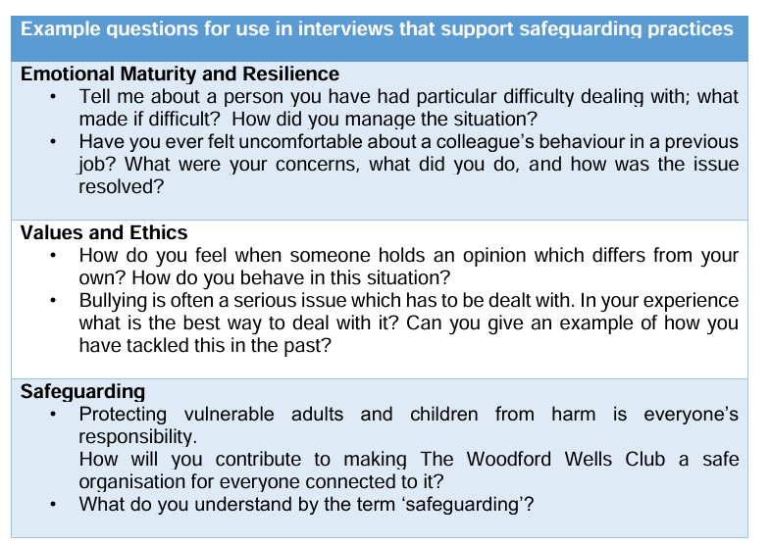
- Pre-Appointment Checks
The nature of the club’s work requires employees to have regular contact children, young people, vulnerable adults, and adults at risk as well as personal data. This creates an inherent risk to the club and the completion of the following pre appointment checks provide assurance to the club and its partners and stakeholders as to the integrity and reliability of those seeking employment within the club.
For consistency and fairness, the club will engage and work alongside a ‘Responsible Organisation’ registered with the Disclosure Barring Service to conduct the suite of checks on a full-service basis including the below:

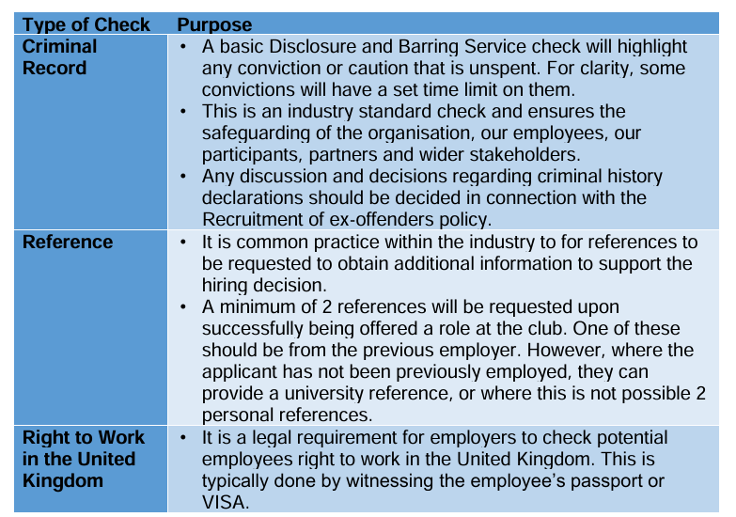

All employees will be required to complete the above checks to remain in their post. New employees who are offered employment by the club will be asked to complete these checks in advance of joining the organisation.
The above screening checks are common practice within safer recruitment and support the club in confirming the integrity of appointments. A record of all checks undertaken for employees will be stored electronically in our Single Central Register.
Where there is a significant change to an employee’s personal circumstance that may impact their vetting, they should raise this with club’s General Manager who will liaise with the HR provider in the first instance to understand if and what steps need to be taken.

Applicants or current employees are welcome to contact the club’s General Manager or HR provider if they have any questions on concerns regarding this policy or the vetting process.
- Pre-Appointment Vetting Failures
The club will apply a risk-based approach to current or prospective employees that fail pre-appointment screening or vetting.
Screening and vetting risks will be managed by the General Manager with the support of the HR provider and highlighted to the General Committee.
Whilst a vetting failure is likely to mean that an offer of employment to a prospective employee is rescinded, for current employees it need not mean dismissal, but instead would prompt a process of risk management.
The club continues to make a commitment to diversity and inclusion across every aspect of the activities, events and trips provided by the club. We appreciate that pre appointment vetting can in some instances cause adverse impact for those from minority ethnic backgrounds, particularly where they or their close relatives live outside of the UK. Instances of pre-appointment vetting failures will be viewed on a case-by case basis and the full context of each situation will be reviewed to minimise any potential adverse impact.
- Making Decisions
All decisions to appoint must be fully agreed by all members of the panel. If the panel cannot agree, then no appointment should be made, or candidate(s) should be invited back for a further interview if there is an element of doubt.
A further interview may be considered in situations where the position could be offered to more than one person who have equal scores.
It will be the responsibility of the person chairing the interviews to notify all candidates of the results of their interview, giving reasons they were unsuccessful if they request this. This can be done via telephone, email, or letter.

If any internal applicants are rejected at this stage face-face feedback will be provided to the candidate.
The person chairing the interviews will telephone the successful candidate to advise them that a conditional job offer is made, and this shall be confirmed in writing.
All offers of employment and associated documentation will be sent out by the General Manager or HR provider. All offer letters will contain the following and accompany a contract of employment, job/role description and person specification:
• Job title of the job being offered
• Any conditions that apply to the offer
• Terms of the offer – salary, hours, placement of employment, etc
• Start date and probationary period (where relevant)
• Action needed to be taken by the candidate, e.g., sign and return one copy of the enclosed forms etc.
- Induction and Training
All new employees will be given an induction programme which will include the club’s policies and procedures and make clear the expectations which will govern how they carry out their roles and responsibilities.
Employees will be made aware of the systems which support safeguarding and safe practices and will be provided with the following policies and procedures as a minimum:
• Code of Conduct
• Anti-Bullying and Harassment Policy
• Lone Working Policy (relevant to the role)
• Safeguarding Policy and Procedures
• Whistleblowing Policy

The club recognises that safer recruitment and selection is not just about the start of a contract of employment but that it is part of a larger policy framework for all employees.
The club will therefore provide initial and ongoing training and support for all employees as identified through the performance management procedures. There are mandatory induction training requirements which include:
• Introduction to the club: Mission, who we are and what we do
• Basic Health & Safety
• Basic Safeguarding
• Equality and Diversity
• Data Protection and Information Security
- Quality Assurance of Recruitment Campaigns
The club is committed to striving for excellence in the provision of all its services. We do this by actively monitoring and reviewing the safeguarding systems in place. The General Committee will be responsible for ensuring that this policy and procedures are monitored and evaluated regularly. This will be undertaken through formal audits of completed recruitment campaigns using the Safer Recruitment Audit checklist (Appendix 1). A summary report will be presented to the General Committee for strategic oversight and to ensure compliance with legislation and guidance.
- Monitoring and Quality Assurance
The club is committed to striving for excellence in the provision of all its activities, events, and trips. We do this by actively monitoring and reviewing the recruitment and safeguarding systems in place. In addition, this policy will be review on a bi-annual basis to ensure they remain reflective of current safeguarding legislation, guidance, and recruitment best practice.
- Linked Police Now Policies and Procedures
This safer recruitment policy is linked to the following policies, procedures and documents and therefore should be read in conjunction:
• Codes of Conduct
• Anti-Bullying and Harassment Policy
• Data Protection and Information Security
• Equality & Diversity Policy
• Lone Working Policy
• Safeguarding Policy and Procedures
• Whistleblowing Policy
Date of Last Review | August 2026 | Owner | General Committee
Review Period | Bi-Annual | Date of Next Review | August 2028

